**EX.NO .3**

**AIM:**Write a program to multiply the given two matrices.

import java.util.Scanner;

public class MatrixMultiplication

{

public static void main(String args[])

{

int n;

Scanner input = new Scanner(System.in);

System.out.println("Enter the base of squared matrices");

n = input.nextInt();

int[][] a = new int[n][n];

int[][] b = new int[n][n];

int[][] c = new int[n][n];

System.out.println("Enter the elements of 1st martix row wise \n");

for (int i = 0; i < n; i++)

{

for (int j = 0; j < n; j++)

{

a[i][j] = input.nextInt();

}

}

System.out.println("Enter the elements of 2nd martix row wise \n");

for (int i = 0; i < n; i++)

{

for (int j = 0; j < n; j++)

{

b[i][j] = input.nextInt();

}

}

System.out.println("Multiplying the matrices...");

for (int i = 0; i < n; i++)

{

for (int j = 0; j < n; j++)

{

for (int k = 0; k < n; k++)

{

c[i][j] = c[i][j] + a[i][k] * b[k][j];

} } }

System.out.println("The product is:");

for (int i = 0; i < n; i++)

{

for (int j = 0; j < n; j++)

{

System.out.print(c[i][j] + " ");

}

System.out.println();

}

input.close();

} }

**SAMPLE OUTPUT**

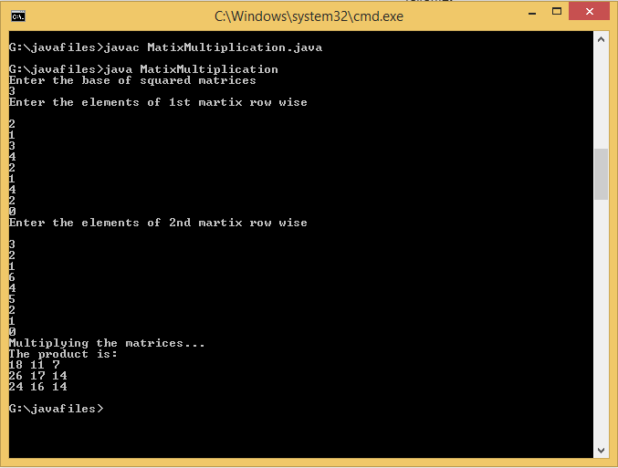

**EX NO:4**

**AIM:** Write a program to design a class to represent a bank account. Include the following:

Data Members: Name of the depositor, Account number, Type of account, and Balance amount in the account.

Methods: To assign initial values, To deposit an amount, To withdraw an amount after checking balance, and To display the name and balance.

import java.io.*;

import java.lang.*;

class Bankprg

{

public double balance=0;

public int accno;

public String name,acc_type;

DataInputStream input=new DataInputStream(System.in);

public void create() throws IOException

{

System.out.println("NEW ACCOUNT");

System.out.println("enter account number");

accno=Integer.parseInt(input.readLine());

System.out.println("enter account type either savings or current");

acc_type=input.readLine();

System.out.println("enter first balance");

balance=Double.parseDouble(input.readLine());

System.out.println("\t your account name:\t");

System.out.println("\t your available balance is:\t"+balance);

System.out.println("\t****************");

}

public void deposit(double d)throws IOException

{

double depo=d;

balance=balance+depo;

System.out.println("\n\t the available balance after deposit:"+balance);

}

public void withdraw(double w)throws IOException

{

double wit=w;

if(balance>=wit)

{

balance=balance-wit;

System.out.println("\t the available balance after withdrawl:"+balance);

}

else

{

System.out.println("insufficient fund");

}

}

void choices()throws IOException

{

int select,temp=1;

DataInputStream input=new DataInputStream(System.in);

do

{

System.out.println();

System.out.println("\n\t...........Bank program........");

System.out.println("\t************");

System.out.println("1.create account");

System.out.println("2.deposit");

System.out.println("3.withdrawl");

System.out.println("4.Balance enquiry");

System.out.println("5.exit");

System.out.println("please enter your choice:");

select=Integer.parseInt(input.readLine());

switch(select)

{

case 1:create();

break;

case 2:

System.out.println("enter the amount to be deposited:");

double depo=Double.parseDouble(input.readLine());

deposit(depo);

break;

case 3:

System.out.println("enter the amount to be withdrawl:");

double wit=Double.parseDouble(input.readLine());

withdraw(wit);

break;

case 4:

System.out.println("your balance Rs."+balance);

break;

case 5:

System.exit(1);

break;

default:

System.out.println("enter your choise between 1to5");

}

}while(temp==1);

}

}

public class Mainprg

{

public static void main(String args[])throws IOException

{

Bankprg menu=new Bankprg();

menu.choices();

menu.create();

}

}

**SAMPLE OUTPUT:**

